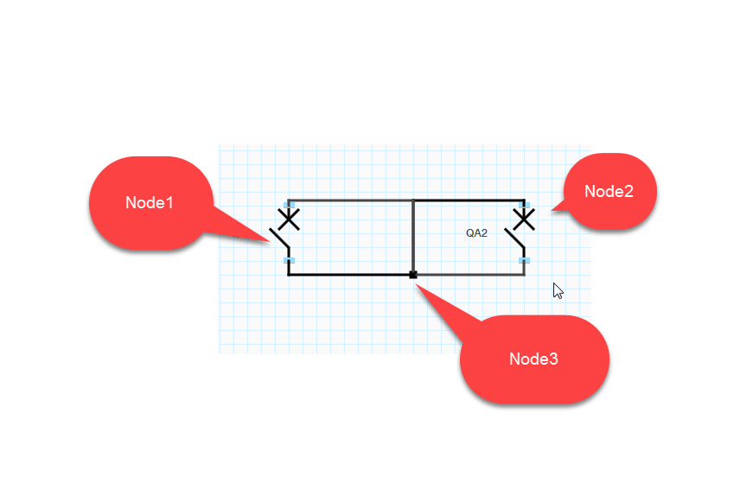

Figure above shows initial state of 3 nodes. Node1 and Node2 has 2 connection points and Node3 can have any number of connection points. When Node3 is moved some times the connection is broken as shown in the figure below. There are only 3 nodes in the diagram. Issue can be reproduced only by moving the Node3 around randomly.

